What’s “Inside” your Favorite Animal Cartoon Character?
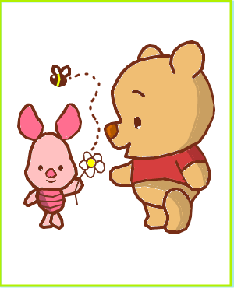
1. Choose a cartoon character and sketch onto your piece of lab paper, front and back. See Mrs. Titus for tracing options.
2. Using our list of muscles draw all the muscles of your cartoon character, both anterior and posterior.
-Think about scale/ appropriate size
-Think about body shape of your cartoon and muscle shape.
- Think about locations of muscles.
3. Label the muscles and draw the fibers in the correct directions for contractions.
4. Create: 10 additional muscles that are not included in human anatomy but WOULD be in your cartoon character. Name the muscles using LADSNOR.
- Think about additional body parts that they may be able to move…
5. List the action, origin and insertion for the 10 new muscles.
6. DESIGN: Create a total body workout plan for your cartoon character (including the 10 new muscles). (That your character could and would do!)
  - At least 10 exercises
  - Name the exercises
  - Describe the exercises
  - List the muscles that are worked in the exercise

