Electromagnetic Spectrum Guided Reading
1. How does electromagnetic radiation move through space?

2. How fast do electromagnetic waves travel?

3. Electromagnetic waves behave like a _____________ and a ________________.
Example

4. How does the wavelength of an electromagnetic wave effect the amount of energy it contains?

Fill in the table
Electromagnetic Wave | Wavelength range | What do these waves tell us about the solar system?
Radio
Infrared
Visible Light
Ultra Violet
X-rays
Gamma waves
5. What is spectroscopy?

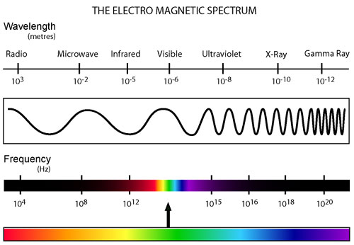
6. What is photometry?
7. Match each kind of wave with one item from column one and one item from column two.

COLUMN 1 |  | WAVE |  | COLUMN 2
A. used in remote controls for TVs and VCRs | _____ | RADIO | _____ | H. used to find a broken bone or illegal plane carry-on
B. goes through most matter  except bone and lead | _____ | MICROWAVE | _____ | I. used to kill bacteria on food
C. highest frequency and  energy | _____ | INFRARED | _____ | J. ROY G. BV
D. can cause skin cancer or promote vitamin D production | _____ | VISIBLE | _____ | K. shortest wavelength
E. longest wavelength | _____ | ULTRAVIOLET | _____ | L. most dangerous waves
F. can be used to increases thermal energy of food in your home. | _____ | X-RAY | _____ | M. TV signals, and used in remote control devices like car alarms and garage door openers
G. wavelengths and frequencies that can be seen by the human eye | _____ | GAMMA | _____ | N. radiant heat rays

8. As you go from left to right across the electromagnetic spectrum what happens to the frequency and energy of the waves? ______________________________________________________________________
9. What happens to the speed of light as it enters a different medium? _____________________________
10. Which color of the visible light portion of the electromagnetic spectrum has the highest frequency and
the most energy? ___________________________________________________________________
11. Which color of the visible light portion of the electromagnetic spectrum has the lowest frequency and
the least energy? ___________________________________________________________________
12. Identify the electromagnetic wave:
A. Frequency of 3.7x 10¹²
B. Wavelength of 5.8x 10⁻⁸
C. Frequency of 9.2x 10⁴
D. Wavelength of 8.7x 10⁻¹²

