Name: _______________________________ Test day: ____________________
1. Describe the general functions of the integumentary system.

2. Describe each layer of the epidermis and explain the functional significance of each.

3. Describe each layer of the dermis and the function of each.

4. Explain what accounts for individual differences in skin, such as skin color.

5. Explain how the integumentary system helps regulate body temperature.

6. Discuss the effects of ultraviolet radiation on the skin and the role played by melanocytes.

7. What are the functions of hair and nails?

8. Compare and contrast sebaceous, aprocine and merocrine glands.

9. Explain how the skin responds to injury and repairs itself.

10. Summarize the effects of the aging process on the skin.

Fill in the blanks:
The two basic tissues of which skin is composed are dense irregular tissue, which makes up the (1) ___________, and (2) ________________, which forms the epidermis. The tough water repellant protein, (3) ____________, produced in the (4) _____________ layer of the (5) ________________. The pigments (6) _______________ and (7) _______________ contribute to skin color and are produced by (8) ___________________. You fingerprints are formed from the (9) _____________ layer of the skin. Sebaceous glands produce (10) _______________, which functions to (11) _______________________. (12)____________________ And (13) ___________________ produce sweat.
Healing of Wounds and Burns
Epidermal and Dermal cells can reproduce because of cells that differentiate called (1)___________. During the first stage of repair, (2) ___________ trigger an inflammatory response. In which the following symptoms would occur: (list three) (4)_______________, (5)_________________, and (6)_______________ . A blood clot will form which functions to (7)_______________________. Cells in the (8) _______________ layer divide to replace missing cells. The combination of blood clot, blood vessels and fibroblasts is called (9) ___________________. Over time the scab will be shed and (10)______________ will remain.

Burn Type | Characteristics | Symptoms
First Degree
Second Degree
Third Degree
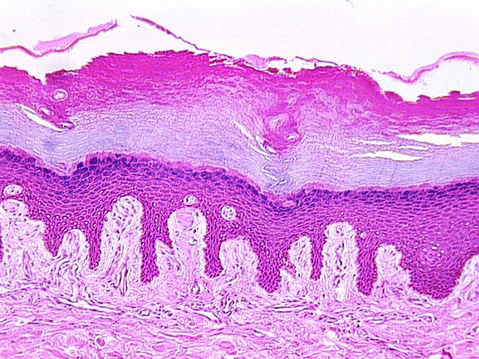
Label and color code each picture:
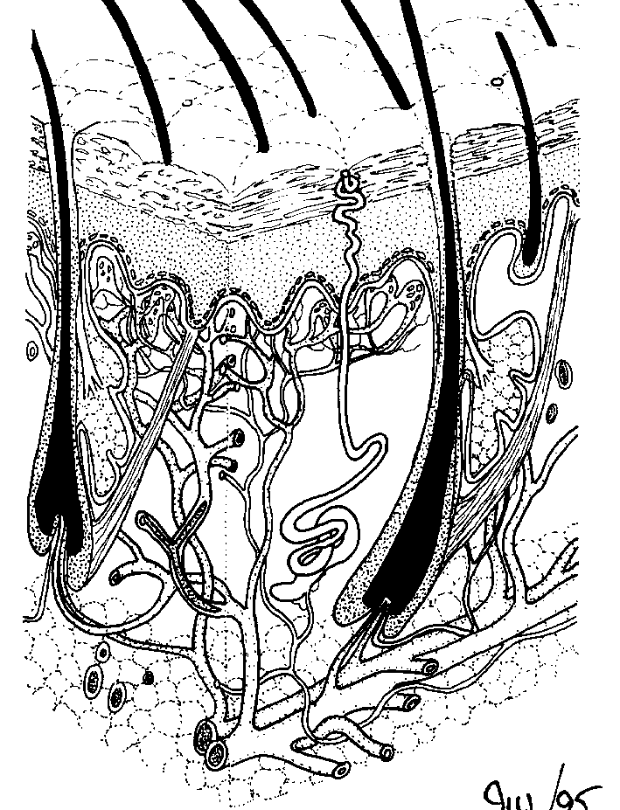
- Stratum corneum
- Stratum granulosum
- Stratum spinosum
- Stratum germintavum
- Dermis

- Arrector Pili muscle
- Adipose tissue
- Epidermis
- Dermis
- Blood Vessel
- Sweat gland
- Sebaceaous Gland
- Hair follicle
- Hair shaft

