Station 1 (TORSO MODEL)
Procedure:
1. Look at the model and identify the following organs before removing the intestines. Next to each organ please indicate the number that is taped to each organ. (So I know you correctly identified the organ!)
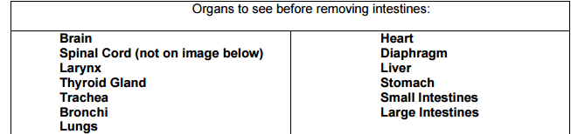
2. Now move on to removing the intestines and identify the following:
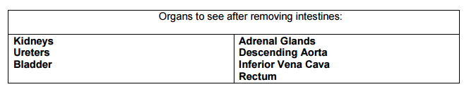
Q1. When you removed the front of the model and look inside, what plane are viewing?

Q2. Which organs are located in the RUQ?

Q3. Which organs are posterior to the small intestines?

Station 2: (Building Medical Terms)
Procedure:
1. Review the background information.
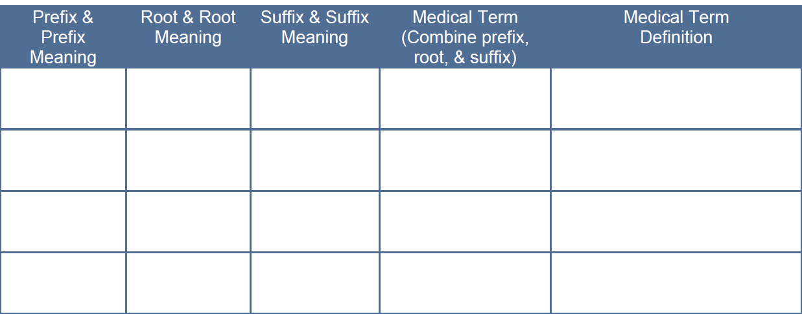
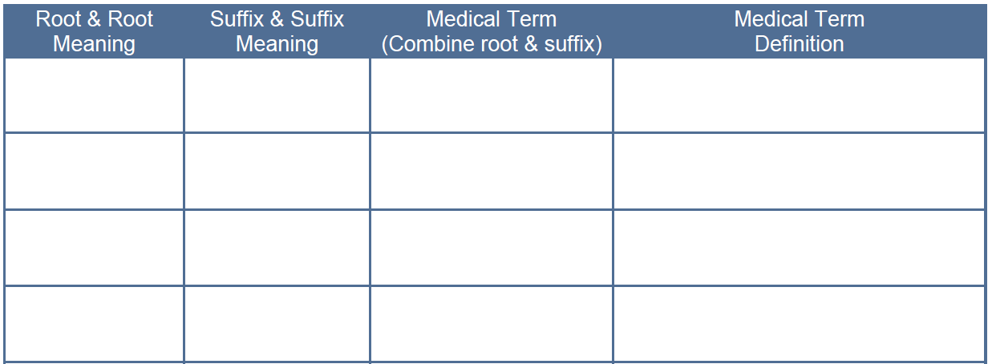
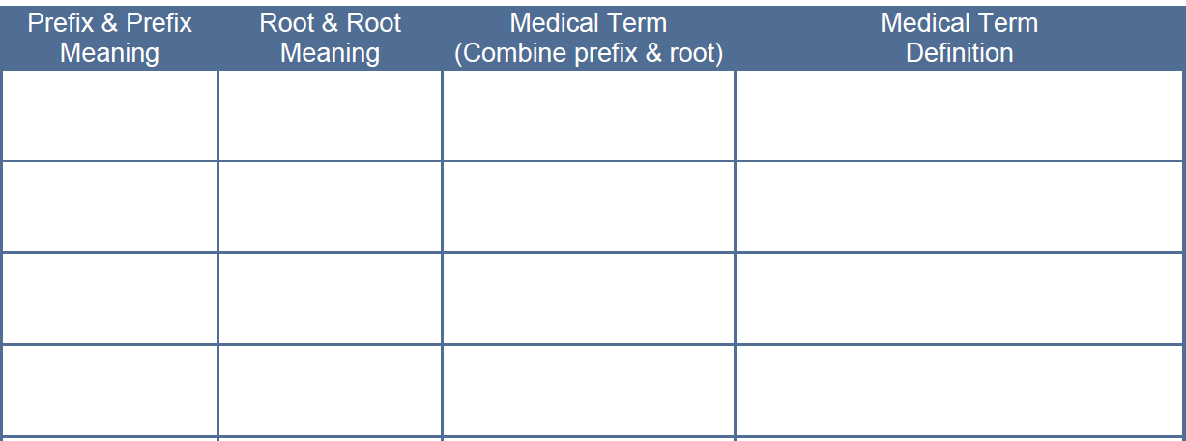
2. Draw a card from the different bags and fill in the chart to create medical terms. (The words will probably not be true medical terms, but follow the rules to create an appropriate medical term.)
Q1. Why is important to recognize prefixes, roots and suffixes?
Q2. Is memorizing terms recommended in Anatomy? Studying?
Station 3: (Defining Medical Terms)
1. Review the background information at the station.
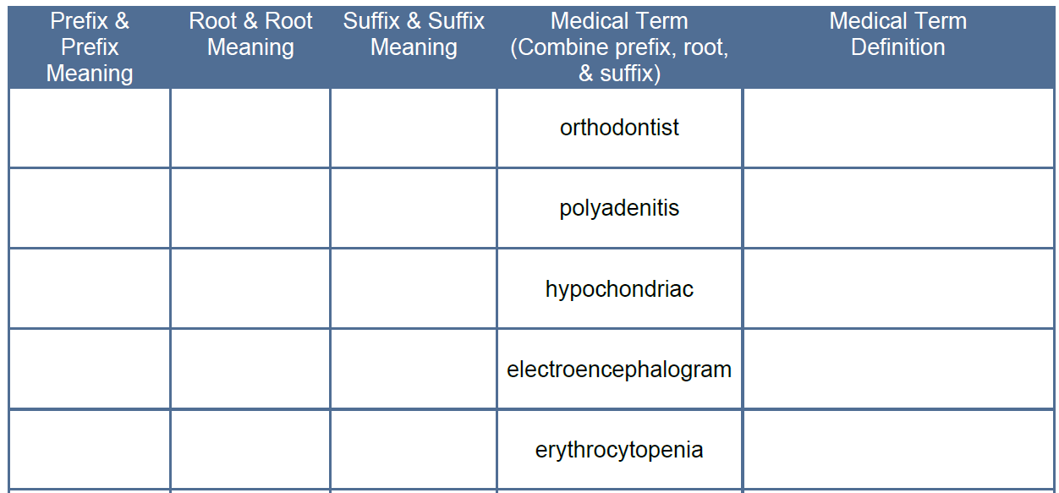
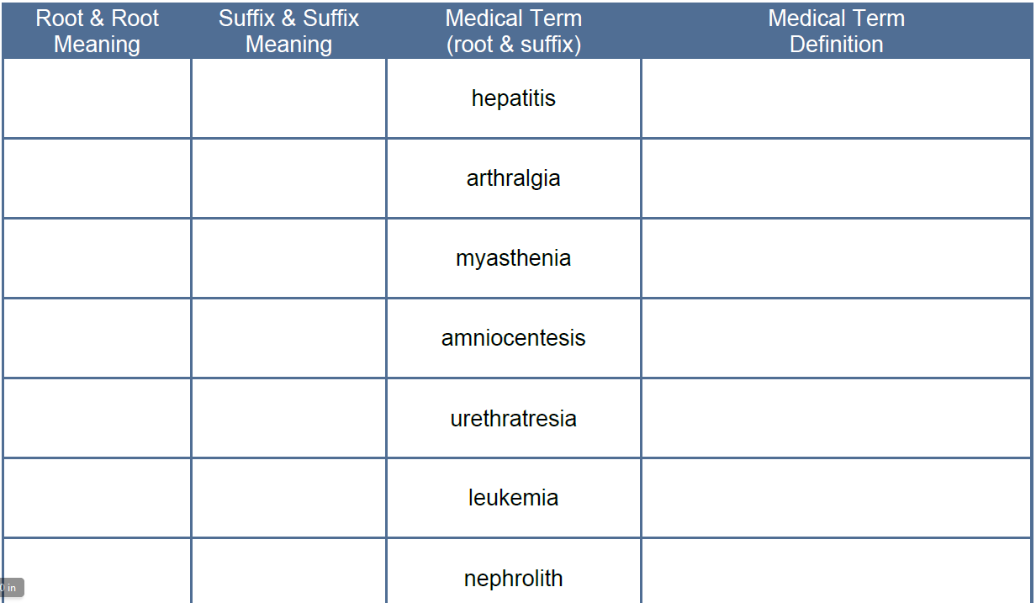
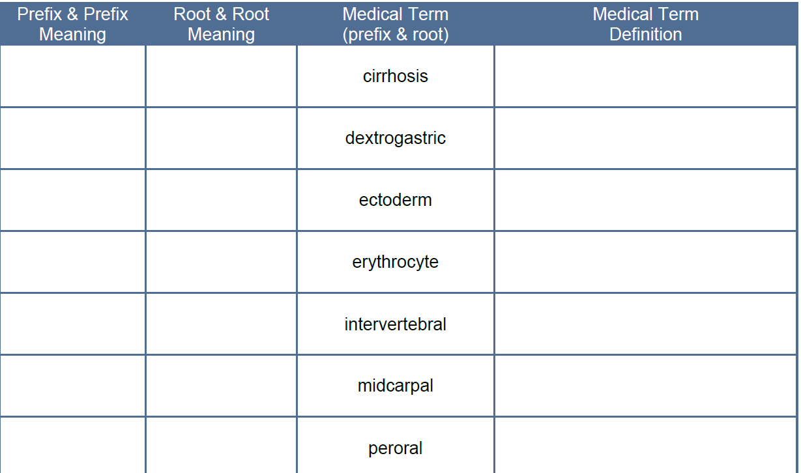
2. Fill in the table using the medical dictionary provided.
Q1. Identify any terms from the lists above that were familiar to you already.

Q2. Did the medical definition match your previous knowledge of the word? Why or Why not?

Station 4: (A medical story)
Procedure:
1. As a team choose 20 of the terms and create a short story that uses the terms appropriately. HIGHLIGHT your words.
2. Please have one member of your team define the 20 chosen words and attach to your story.
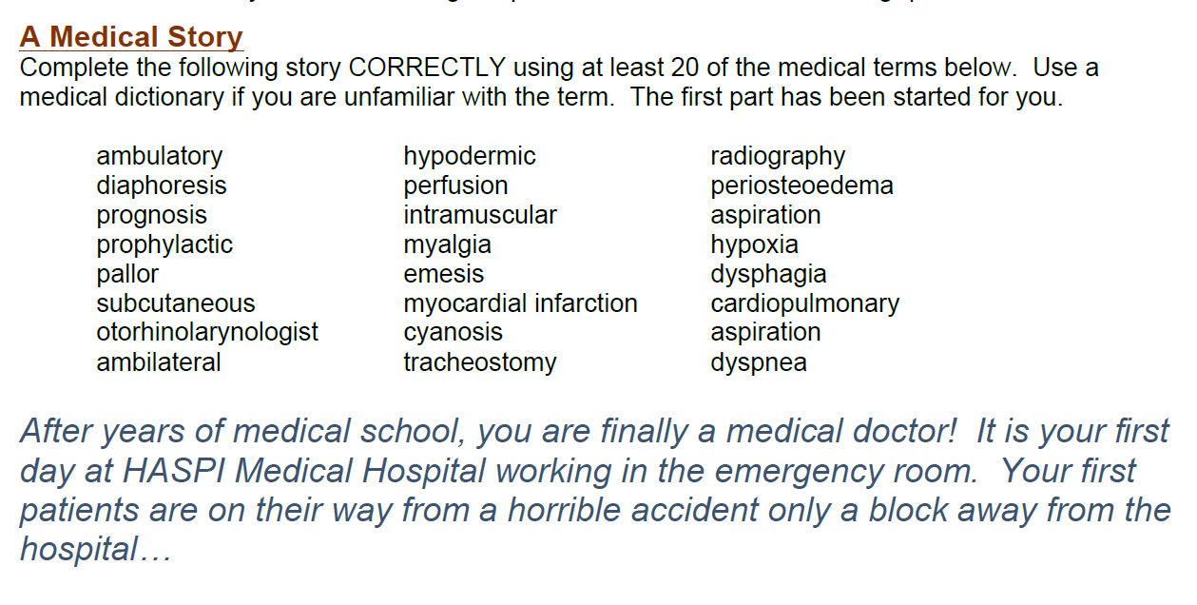

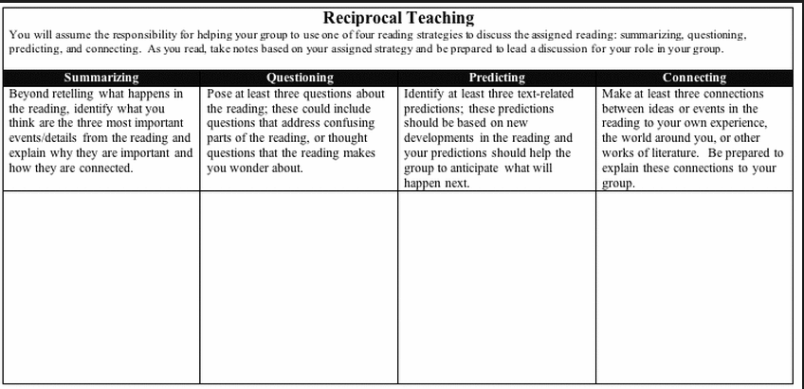
Station 5: Article Questions- Choose one card and complete your section of the sheet. Then discuss the reading with your group and fill in the information during the discussion. Then switch roles and complete using the video clip.
Station 6: 