Name: __________________________ Date: __________________________________
PART 1- Word List:

Disease
Sign
Symptom
Diagnosis
Prognosis
Pathogen

Homeostasis

Use each word from the word list in one of the sentence starters and then complete the sentence in a way that relates to anatomy and physiology. (There are many correct answers).
- One similarity between a (word list)______________________ and (your choice)____________________ is _________________________________________________.
- _______________________ consists of the following examples: __________________, ______________ and __________________________.
- The _____________________ is important because ___________________________________.
- (word list)______________________ and (word list)_______________________ are different in that they ______________________________________________________________________________.
- An example of ____________________ would be _____________________________________.
- This (word list)_____________________ reminds me of ________________________________ because _______________________________________________________________________.
Part 2- DRAW A PICTURE TO REPRESENT EACH ROOT WORD:

a-
ant-
brady-
endo-
epi-
hyper-
hypo-
inter-
iso-
myo-
osteo-
cardi-
peri-
pulmo-
tachy-
– algia
- dermis
–tomy
–globin
thrombo-
hem-

Part 3- Use the word list and match it up to a picture that you think represents the word and why.
You may use pictures more than once. (many correct answers)
Anterior
Posterior
Dorsal
Ventral
Superior
Inferior
Medial
Lateral
Proximal
Distal
Superficial
Deep
Transverse
Frontal
Sagittal

 |  | 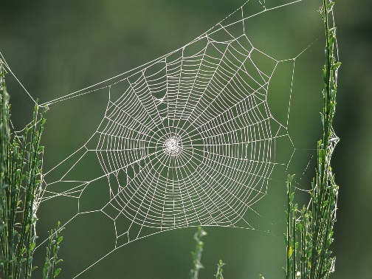
 | 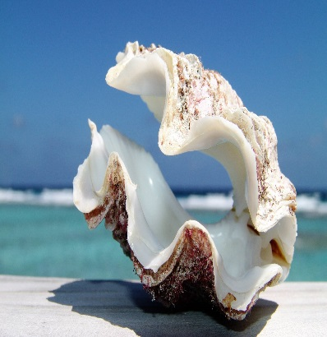
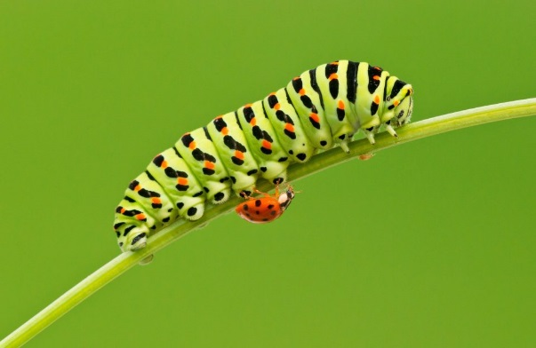
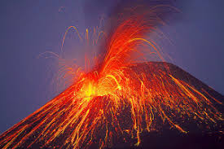 |  | 